Week-02 HandsOn Solution

- Advanced SQL Server

File 1: Advanced Concepts

Exercise-1: Ranking and Window Functions

- Code:

//Database Creation:

CREATE DATABASE OnlineRetailStore;
GO

USE OnlineRetailStore;
GO

CREATE TABLE Products (
ProductID INT IDENTITY(1,1) PRIMARY KEY,
ProductName NVARCHAR(100) NOT NULL,
Category NVARCHAR(50) NOT NULL,
Price DECIMAL(10,2) NOT NULL,
Brand NVARCHAR(50) NOT NULL,
StockQuantity INT DEFAULT 0,
CreatedDate DATETIME2 DEFAULT GETDATE()
);
GO

INSERT INTO Products (ProductName, Category, Price, Brand, StockQuantity) VALUES
-- Electronics Category
('iPhone 15 Pro', 'Electronics', 1199.99, 'Apple', 50),
('Samsung Galaxy S24', 'Electronics', 999.99, 'Samsung', 75),
('MacBook Pro 16"', 'Electronics', 2499.99, 'Apple', 25),
('Dell XPS 13', 'Electronics', 1299.99, 'Dell', 30),

-- Clothing Category
('Nike Air Max', 'Clothing', 129.99, 'Nike', 100),
('Levi''s 501 Jeans', 'Clothing', 89.99, 'Levis', 150),
('Adidas Ultraboost', 'Clothing', 180.00, 'Adidas', 80),
('North Face Jacket', 'Clothing', 249.99, 'North Face', 45),

-- Home & Garden Category
('Dyson V15 Vacuum', 'Home & Garden', 749.99, 'Dyson', 35),
('KitchenAid Mixer', 'Home & Garden', 399.99, 'KitchenAid', 25),
('Instant Pot Pro', 'Home & Garden', 149.99, 'Instant Pot', 60),
('Roomba i7+', 'Home & Garden', 599.99, 'iRobot', 15),

-- Sports Category
('Peloton Bike', 'Sports', 1445.00, 'Peloton', 10),
('Bowflex Dumbbells', 'Sports', 349.99, 'Bowflex', 25),
('Yoga Mat Premium', 'Sports', 79.99, 'Manduka', 150),
('Resistance Bands Set', 'Sports', 29.99, 'Fit Simplify', 200);
GO

SELECT 'Database and table created successfully!' AS Status;

SELECT
'Total Products: ' + CAST(COUNT(*) AS VARCHAR(10)) AS Summary
FROM Products;

SELECT
Category,
COUNT(*) AS ProductCount,
MIN(Price) AS MinPrice,
MAX(Price) AS MaxPrice
FROM Products
GROUP BY Category
ORDER BY Category;

//Query:

USE OnlineRetailStore;
GO

SELECT 'ROW_NUMBER() - Assigns unique sequential ranks' AS RankingType;

SELECT
ProductID,
ProductName,
Category,
Price,
Brand,
ROW_NUMBER() OVER (PARTITION BY Category ORDER BY Price DESC) AS RowNum
FROM Products
ORDER BY Category, Price DESC;
GO

SELECT 'RANK() - Leaves gaps after tied ranks' AS RankingType;

SELECT
ProductID,
ProductName,
Category,
Price,
Brand,
RANK() OVER (PARTITION BY Category ORDER BY Price DESC) AS RankNum
FROM Products
ORDER BY Category, Price DESC;
GO

SELECT 'DENSE_RANK() - No gaps after tied ranks' AS RankingType;

SELECT
ProductID,
ProductName,
Category,
Price,
Brand,
DENSE_RANK() OVER (PARTITION BY Category ORDER BY Price DESC) AS DenseRankNum
FROM Products
ORDER BY Category, Price DESC;
GO

SELECT 'COMPARISON: All Three Ranking Functions' AS ComparisonType;

SELECT
ProductID,
ProductName,
Category,
Price,
Brand,
ROW_NUMBER() OVER (PARTITION BY Category ORDER BY Price DESC) AS RowNum,
RANK() OVER (PARTITION BY Category ORDER BY Price DESC) AS RankNum,
DENSE_RANK() OVER (PARTITION BY Category ORDER BY Price DESC) AS DenseRankNum
FROM Products
ORDER BY Category, Price DESC;
GO

SELECT 'TOP 3 Products per Category using ROW_NUMBER()' AS ResultType;

WITH RankedProducts AS (
SELECT
ProductID,
ProductName,
Category,
Price,
Brand,
StockQuantity,
ROW_NUMBER() OVER (PARTITION BY Category ORDER BY Price DESC) AS RowNum
FROM Products
)
SELECT
ProductID,
ProductName,
Category,
Price,
Brand,
StockQuantity,
RowNum
FROM RankedProducts
WHERE RowNum <= 3
ORDER BY Category, RowNum;
GO

SELECT 'TOP 3 Products per Category using RANK()' AS ResultType;

WITH RankedProducts AS (
SELECT
ProductID,
ProductName,
Category,
Price,
Brand,
StockQuantity,
RANK() OVER (PARTITION BY Category ORDER BY Price DESC) AS RankNum
FROM Products
)
SELECT
ProductID,
ProductName,
Category,
Price,
Brand,
StockQuantity,
RankNum
FROM RankedProducts
WHERE RankNum <= 3
ORDER BY Category, RankNum;
GO

SELECT 'TOP 3 Products per Category using DENSE_RANK()' AS ResultType;

WITH RankedProducts AS (
SELECT
ProductID,
ProductName,
Category,
Price,
Brand,
StockQuantity,
DENSE_RANK() OVER (PARTITION BY Category ORDER BY Price DESC) AS DenseRankNum
FROM Products
)
SELECT
ProductID,
ProductName,
Category,
Price,
Brand,
StockQuantity,
DenseRankNum
FROM RankedProducts
WHERE DenseRankNum <= 3
ORDER BY Category, DenseRankNum;
GO

- Output:

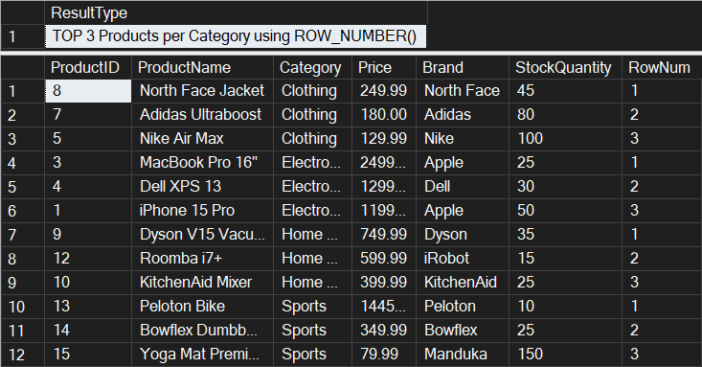

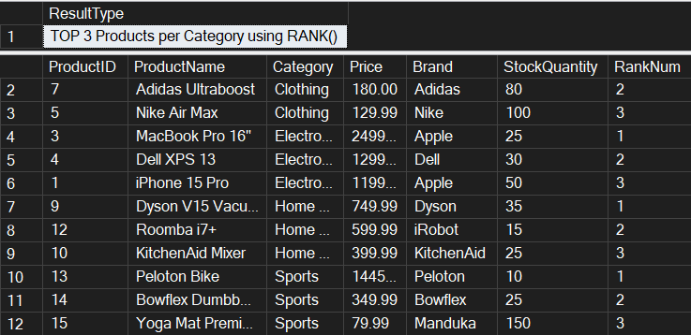

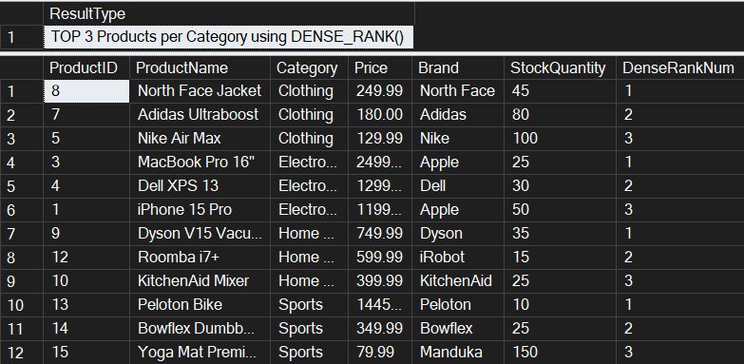
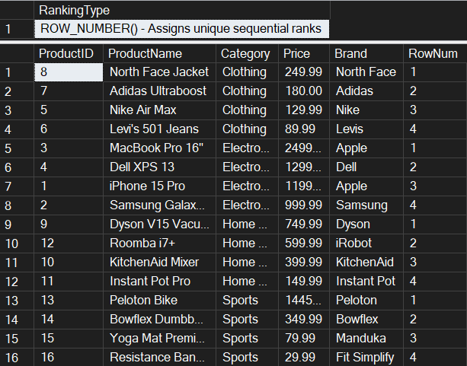

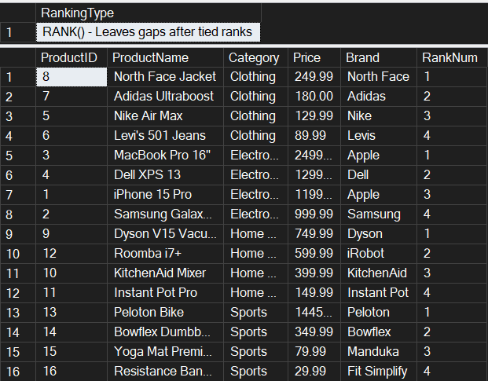

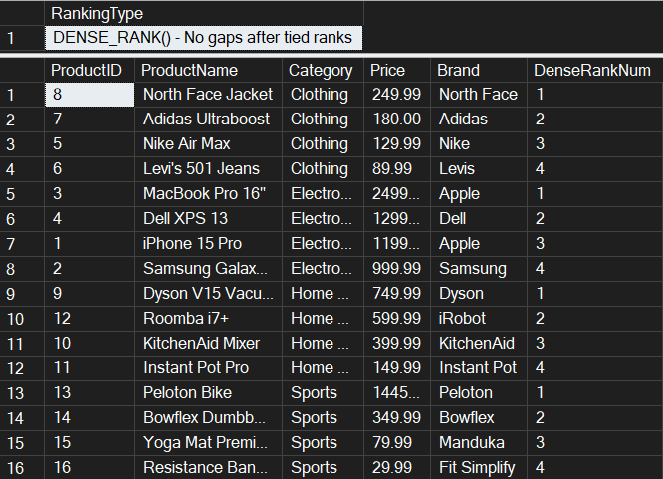

File 4: Stored procedure

//Database Creation:

CREATE DATABASE EmployeeManagementSystem;
GO

USE EmployeeManagementSystem;
GO

CREATE TABLE Departments (
DepartmentID INT PRIMARY KEY,
DepartmentName VARCHAR(100)
);
GO

CREATE TABLE Employees (
EmployeeID INT PRIMARY KEY,
FirstName VARCHAR(50),
LastName VARCHAR(50),
DepartmentID INT FOREIGN KEY REFERENCES Departments(DepartmentID),
Salary DECIMAL(10,2),
JoinDate DATE
);
GO

INSERT INTO Departments (DepartmentID, DepartmentName) VALUES
(1, 'HR'),
(2, 'Finance'),
(3, 'IT'),
(4, 'Marketing');
GO

INSERT INTO Employees (EmployeeID, FirstName, LastName, DepartmentID, Salary, JoinDate) VALUES
(1, 'John', 'Doe', 1, 5000.00, '2020-01-15'),
(2, 'Jane', 'Smith', 2, 6000.00, '2019-03-22'),
(3, 'Michael', 'Johnson', 3, 7000.00, '2018-07-30'),
(4, 'Emily', 'Davis', 4, 5500.00, '2021-11-05'),
(5, 'Robert', 'Wilson', 1, 4800.00, '2020-05-12'),
(6, 'Sarah', 'Brown', 2, 6200.00, '2019-08-14'),
(7, 'David', 'Miller', 3, 7500.00, '2018-12-01'),
(8, 'Lisa', 'Anderson', 1, 5200.00, '2021-02-28'),
(9, 'Kevin', 'Taylor', 3, 6800.00, '2020-09-15'),
(10, 'Maria', 'Garcia', 4, 5800.00, '2021-06-10');
GO

Exercise-01: Create a Stored Procedure

- Code:

Use EmployeeManagementSystem;
GO

PRINT 'Creating Exercise 1 stored procedures...';

IF OBJECT_ID('sp_GetEmployeesByDepartment', 'P') IS NOT NULL
DROP PROCEDURE sp_GetEmployeesByDepartment;
GO

IF OBJECT_ID('sp_InsertEmployee', 'P') IS NOT NULL
DROP PROCEDURE sp_InsertEmployee;
GO

CREATE PROCEDURE sp_GetEmployeesByDepartment
@DepartmentID INT
AS
BEGIN
SET NOCOUNT ON;

-- Validate input
IF @DepartmentID IS NULL
BEGIN
RAISERROR('DepartmentID cannot be NULL', 16, 1);
RETURN;
END

-- Check if department exists
IF NOT EXISTS (SELECT 1 FROM Departments WHERE DepartmentID = @DepartmentID)
BEGIN
RAISERROR('Department with ID %d does not exist', 16, 1, @DepartmentID);
RETURN;
END

-- Return employee details
SELECT
e.EmployeeID,
e.FirstName,
e.LastName,
e.DepartmentID,
d.DepartmentName,
e.Salary,
e.JoinDate
FROM Employees e
INNER JOIN Departments d ON e.DepartmentID = d.DepartmentID
WHERE e.DepartmentID = @DepartmentID
ORDER BY e.LastName, e.FirstName;
END;
GO

-- Create sp_InsertEmployee
CREATE PROCEDURE sp_InsertEmployee
@FirstName VARCHAR(50),
@LastName VARCHAR(50),
@DepartmentID INT,
@Salary DECIMAL(10,2),
@JoinDate DATE
AS
BEGIN
-- Validate department exists
IF NOT EXISTS (SELECT 1 FROM Departments WHERE DepartmentID = @DepartmentID)
BEGIN
RAISERROR('Department with ID %d does not exist', 16, 1, @DepartmentID);
RETURN;
END

-- Get next available EmployeeID
DECLARE @NextEmployeeID INT;
SELECT @NextEmployeeID = ISNULL(MAX(EmployeeID), 0) + 1 FROM Employees;

-- Insert new employee
INSERT INTO Employees (EmployeeID, FirstName, LastName, DepartmentID, Salary, JoinDate)
VALUES (@NextEmployeeID, @FirstName, @LastName, @DepartmentID, @Salary, @JoinDate);
END;
GO
PRINT 'Stored procedures created successfully';
- Output:

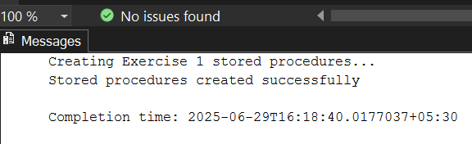

Exercise 4: Execute a Stored Procedure

- Code:

USE EmployeeManagementSystem;
GO

PRINT '=== EXECUTING STORED PROCEDURES ===';
PRINT '';

IF OBJECT_ID('sp_GetEmployeesByDepartment', 'P') IS NULL
BEGIN
PRINT 'ERROR: sp_GetEmployeesByDepartment procedure does not exist!';
PRINT 'Please run Exercise 1 solution first to create the stored procedure.';
RETURN;
END
ELSE
PRINT 'sp_GetEmployeesByDepartment procedure found - Ready to execute';

PRINT '';

-- Execute for HR Department (DepartmentID = 1)
PRINT '--- Executing sp_GetEmployeesByDepartment for HR Department (ID: 1) ---';
EXEC sp_GetEmployeesByDepartment @DepartmentID = 1;

PRINT '';

-- Execute for Finance Department (DepartmentID = 2)
PRINT '--- Executing sp_GetEmployeesByDepartment for Finance Department (ID: 2) ---';
EXEC sp_GetEmployeesByDepartment @DepartmentID = 2;

PRINT '';

-- Execute for IT Department (DepartmentID = 3)
PRINT '--- Executing sp_GetEmployeesByDepartment for IT Department (ID: 3) ---';
EXEC sp_GetEmployeesByDepartment @DepartmentID = 3;

PRINT '';

-- Execute for Marketing Department (DepartmentID = 4)
PRINT '--- Executing sp_GetEmployeesByDepartment for Marketing Department (ID: 4) ---';
EXEC sp_GetEmployeesByDepartment @DepartmentID = 4;

PRINT '';
PRINT '--- Alternative Execution Methods ---';
PRINT 'Method 1 - Using positional parameter for IT Department:';
EXEC sp_GetEmployeesByDepartment 3;

PRINT '';

PRINT 'Method 2 - Using EXECUTE keyword for HR Department:';
EXECUTE sp_GetEmployeesByDepartment @DepartmentID = 1;

PRINT '';

PRINT 'Method 3 - Dynamic execution based on department name:';

-- Get department ID for 'Finance' and execute
DECLARE @DeptID INT;
SELECT @DeptID = DepartmentID FROM Departments WHERE DepartmentName = 'Finance';

PRINT 'Executing for Finance Department (Dynamic ID lookup):';
EXEC sp_GetEmployeesByDepartment @DepartmentID = @DeptID;

PRINT '';

-- Test with invalid department ID
PRINT 'Testing with invalid Department ID (999):';
BEGIN TRY
EXEC sp_GetEmployeesByDepartment @DepartmentID = 999;
END TRY
BEGIN CATCH
PRINT 'Error caught: ' + ERROR_MESSAGE();
END CATCH

PRINT '';

-- Test with NULL parameter
PRINT 'Testing with NULL parameter:';
BEGIN TRY
EXEC sp_GetEmployeesByDepartment @DepartmentID = NULL;
END TRY
BEGIN CATCH
PRINT 'Error caught: ' + ERROR_MESSAGE();
END CATCH

PRINT '';

PRINT '--- Verification: Count of Results per Department ---';

-- Count employees returned by each department execution
SELECT
'HR' AS Department,
COUNT(*) AS EmployeeCount
FROM Employees
WHERE DepartmentID = 1

UNION ALL

SELECT
'Finance' AS Department,
COUNT(*) AS EmployeeCount
FROM Employees
WHERE DepartmentID = 2

UNION ALL

SELECT
'IT' AS Department,
COUNT(*) AS EmployeeCount
FROM Employees
WHERE DepartmentID = 3

UNION ALL

SELECT
'Marketing' AS Department,
COUNT(*) AS EmployeeCount
FROM Employees
WHERE DepartmentID = 4;

PRINT '';

PRINT '--- Advanced Usage: Capturing and Analyzing Results ---';

-- Create a temporary table to store results
IF OBJECT_ID('tempdb..#TempEmployeeResults') IS NOT NULL
DROP TABLE #TempEmployeeResults;

CREATE TABLE #TempEmployeeResults (
EmployeeID INT,
FirstName VARCHAR(50),
LastName VARCHAR(50),
DepartmentID INT,
DepartmentName VARCHAR(100),
Salary DECIMAL(10,2),
JoinDate DATE
);

-- Insert results from stored procedure into temp table
INSERT INTO #TempEmployeeResults
EXEC sp_GetEmployeesByDepartment @DepartmentID = 3;

-- Analyze the captured results
PRINT 'Analysis of IT Department employees (captured from stored procedure):';
SELECT
COUNT(*) AS TotalEmployees,
AVG(Salary) AS AverageSalary,
MIN(JoinDate) AS EarliestJoinDate,
MAX(JoinDate) AS LatestJoinDate
FROM #TempEmployeeResults;

-- Show the captured data
SELECT 'Captured Employee Data:' AS Info;
SELECT * FROM #TempEmployeeResults ORDER BY LastName;

-- Clean up
DROP TABLE #TempEmployeeResults;
PRINT '';
PRINT 'All stored procedure executions completed with results reviewed.';
-- Summary Report
PRINT '';
PRINT '--- SUMMARY REPORT ---';
SELECT
d.DepartmentName,
COUNT(e.EmployeeID) AS TotalEmployees,
'EXEC sp_GetEmployeesByDepartment @DepartmentID = ' + CAST(d.DepartmentID AS VARCHAR(5)) AS ExecutionCommand
FROM Departments d
LEFT JOIN Employees e ON d.DepartmentID = e.DepartmentID
GROUP BY d.DepartmentID, d.DepartmentName
ORDER BY d.DepartmentID;

- Output:

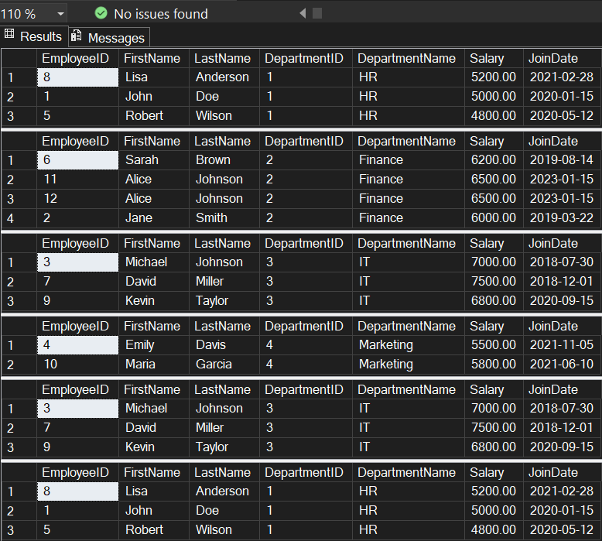
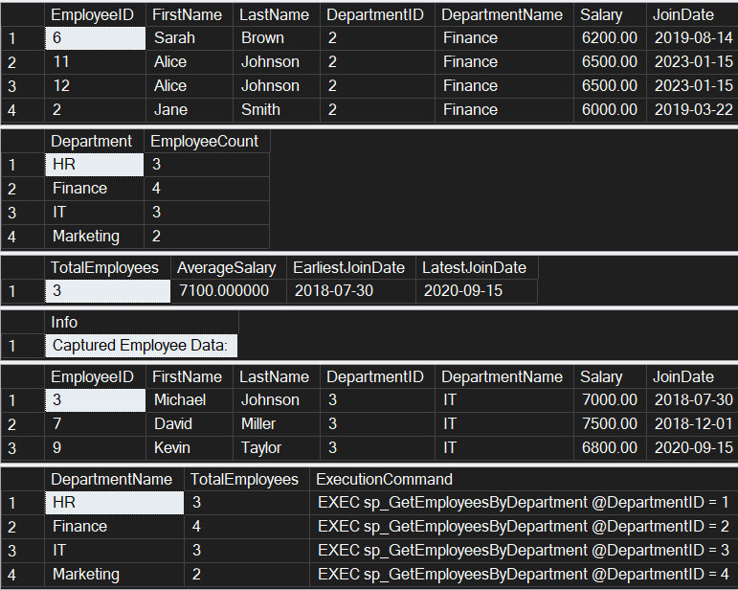
Exercise 5: Return Data from a Stored Procedure

- Code:

Use EmployeeManagementSystem;
GO

PRINT 'Creating Exercise 5 Stored Procedure...';

IF OBJECT_ID('sp_GetEmployeeCountByDepartment', 'P') IS NOT NULL
DROP PROCEDURE sp_GetEmployeeCountByDepartment;
GO

-- Create stored procedure that returns the total number of employees in a department
CREATE PROCEDURE sp_GetEmployeeCountByDepartment
@DepartmentID INT
AS
BEGIN
SET NOCOUNT ON;

-- Validate input parameter
IF @DepartmentID IS NULL
BEGIN
PRINT 'Error: DepartmentID cannot be NULL';
RETURN;
END

-- Check if department exists
IF NOT EXISTS (SELECT 1 FROM Departments WHERE DepartmentID = @DepartmentID)
BEGIN
PRINT 'Error: Department with ID ' + CAST(@DepartmentID AS VARCHAR(10)) + ' does not exist';
RETURN;
END

-- Declare variables for department info
DECLARE @DepartmentName VARCHAR(100);
DECLARE @EmployeeCount INT;

-- Get department name
SELECT @DepartmentName = DepartmentName
FROM Departments
WHERE DepartmentID = @DepartmentID;

-- Count employees in the specified department
SELECT @EmployeeCount = COUNT(*)
FROM Employees
WHERE DepartmentID = @DepartmentID;

-- Return the count as a result set
SELECT
@DepartmentID AS DepartmentID,
@DepartmentName AS DepartmentName,
@EmployeeCount AS TotalEmployees;

-- Also return individual employee details for reference
SELECT
'Employee Details:' AS Info,
e.EmployeeID,
e.FirstName + ' ' + e.LastName AS FullName,
e.Salary,
e.JoinDate
FROM Employees e
WHERE e.DepartmentID = @DepartmentID
ORDER BY e.LastName, e.FirstName;
-- Print summary message
PRINT 'Department: ' + @DepartmentName + ' has ' + CAST(@EmployeeCount AS VARCHAR(10)) + ' employees';
END;
GO

PRINT 'Exercise 5 stored procedure created successfully!';

-- TESTING THE STORED PROCEDURES
PRINT '=== TESTING EXERCISE 1 STORED PROCEDURES ===';

-- Test sp_GetEmployeesByDepartment
PRINT 'Testing sp_GetEmployeesByDepartment for HR Department (ID: 1):';
EXEC sp_GetEmployeesByDepartment @DepartmentID = 1;

PRINT '';
PRINT 'Testing sp_GetEmployeesByDepartment for IT Department (ID: 3):';
EXEC sp_GetEmployeesByDepartment @DepartmentID = 3;

PRINT '';
PRINT 'Testing sp_InsertEmployee - Adding a new employee:';
EXEC sp_InsertEmployee
@FirstName = 'Alice',
@LastName = 'Johnson',
@DepartmentID = 2,
@Salary = 6500.00,
@JoinDate = '2023-01-15';

PRINT '';
PRINT '=== TESTING EXERCISE 5 STORED PROCEDURE ===';

-- Test sp_GetEmployeeCountByDepartment for each department
PRINT 'Testing sp_GetEmployeeCountByDepartment for HR Department (ID: 1):';
EXEC sp_GetEmployeeCountByDepartment @DepartmentID = 1;

PRINT '';
PRINT 'Testing sp_GetEmployeeCountByDepartment for Finance Department (ID: 2):';
EXEC sp_GetEmployeeCountByDepartment @DepartmentID = 2;

PRINT '';
PRINT 'Testing sp_GetEmployeeCountByDepartment for IT Department (ID: 3):';
EXEC sp_GetEmployeeCountByDepartment @DepartmentID = 3;

PRINT '';
PRINT 'Testing sp_GetEmployeeCountByDepartment for Marketing Department (ID: 4):';
EXEC sp_GetEmployeeCountByDepartment @DepartmentID = 4;

-- ERROR TESTING

PRINT '';
PRINT '=== ERROR TESTING ===';

PRINT 'Testing with invalid department ID (999):';
EXEC sp_GetEmployeesByDepartment @DepartmentID = 999;

PRINT '';
PRINT 'Testing employee count with invalid department ID (999):';
EXEC sp_GetEmployeeCountByDepartment @DepartmentID = 999;

-- SUMMARY REPORT
PRINT '';
PRINT '=== FINAL SUMMARY ===';

SELECT 'DEPARTMENT SUMMARY:' AS ReportType;
SELECT
d.DepartmentID,
d.DepartmentName,
COUNT(e.EmployeeID) AS TotalEmployees,
AVG(e.Salary) AS AverageSalary,
MIN(e.Salary) AS MinSalary,
MAX(e.Salary) AS MaxSalary,
SUM(e.Salary) AS TotalSalaryBudget
FROM Departments d
LEFT JOIN Employees e ON d.DepartmentID = e.DepartmentID
GROUP BY d.DepartmentID, d.DepartmentName
ORDER BY d.DepartmentID;

- Output:

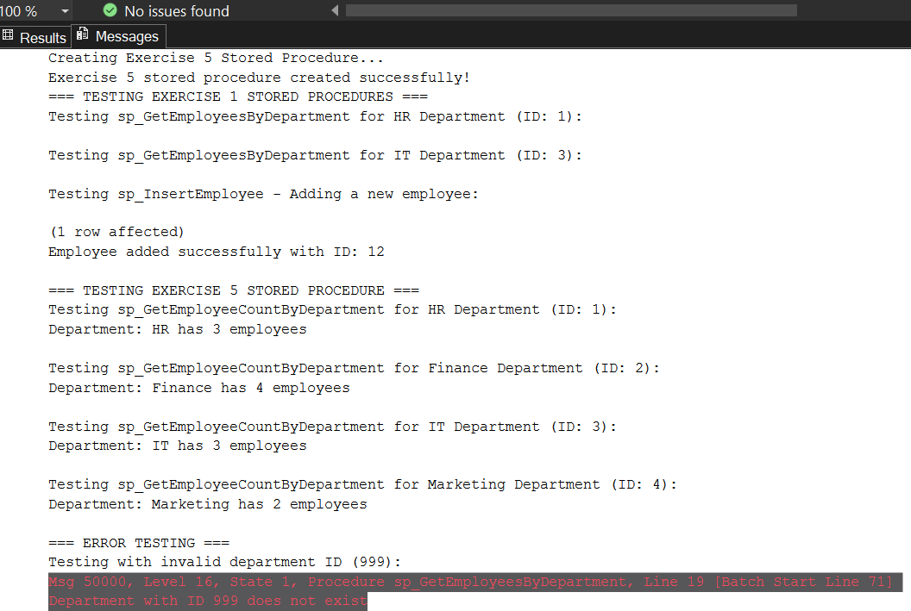
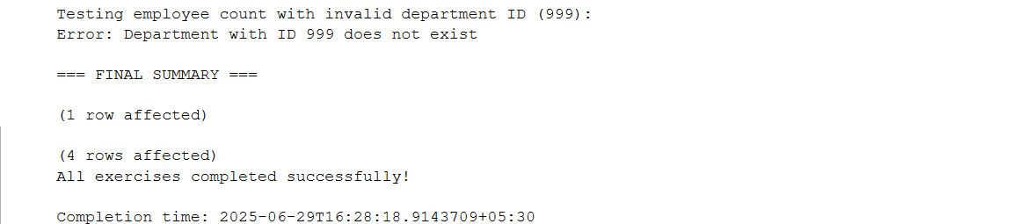

File 5: Functions

Exercise 7: Return Data from a Scalar Function
- Code:

USE EmployeeManagementSystem;
GO

-- Drop function if it already exists
IF OBJECT_ID('dbo.fn_CalculateAnnualSalary', 'FN') IS NOT NULL
BEGIN
DROP FUNCTION dbo.fn_CalculateAnnualSalary;
PRINT 'Existing function dropped';
END
GO
-- Create the fn_CalculateAnnualSalary scalar function
CREATE FUNCTION dbo.fn_CalculateAnnualSalary(@Salary DECIMAL(10,2))
RETURNS DECIMAL(12,2)
AS
BEGIN
RETURN @Salary * 12;
END;
GO

PRINT 'fn_CalculateAnnualSalary function created successfully';

-- Solution 1: Basic query for EmployeeID = 1
SELECT
EmployeeID,
FirstName,
LastName,
Salary AS MonthlySalary,
dbo.fn_CalculateAnnualSalary(Salary) AS AnnualSalary
FROM Employees
WHERE EmployeeID = 1;

-- Solution 2: More detailed query with department information
SELECT
e.EmployeeID,
e.FirstName + ' ' + e.LastName AS FullName,
d.DepartmentName,
e.Salary AS MonthlySalary,
dbo.fn_CalculateAnnualSalary(e.Salary) AS AnnualSalary,
e.JoinDate
FROM Employees e
INNER JOIN Departments d ON e.DepartmentID = d.DepartmentID
WHERE e.EmployeeID = 1;
-- Solution 3: Direct function call with the salary of EmployeeID = 1
SELECT dbo.fn_CalculateAnnualSalary(5000.00) AS AnnualSalaryForEmployee1;
-- Verification: Test the function with all employees to ensure it works correctly
PRINT 'Verification - Annual salary for all employees:';
SELECT
e.EmployeeID,
e.FirstName + ' ' + e.LastName AS EmployeeName,
d.DepartmentName,
e.Salary AS MonthlySalary,
dbo.fn_CalculateAnnualSalary(e.Salary) AS AnnualSalary
FROM Employees e
INNER JOIN Departments d ON e.DepartmentID = d.DepartmentID
ORDER BY e.EmployeeID;

- Output:

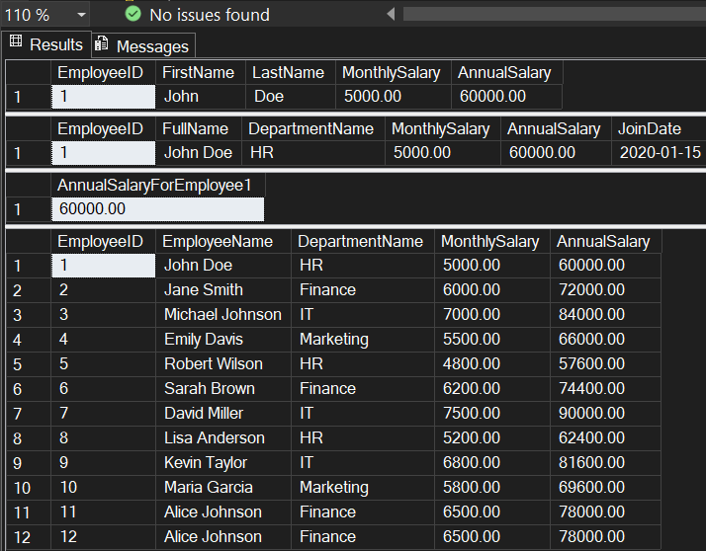

- Moq

1. Write Testable Code with Moq :

CustomerCommLib / MailSender.cs

using System.Net;
using System.Net.Mail;

namespace CustomerCommLib
{
public interface IMailSender
{
bool SendMail(string toAddress, string message);
}

public class MailSender : IMaiSender
{
public bool SendMail(string toAddress, string message)
{
MailMessage mail = new MailMessage();
SmtpClient SmtpServer = new SmtpClient("smtp.gmail.com");

mail.From = new MailAddress("your_email_address@gmail.com");
mail.To.Add(toAddress);
mail.Subject = "Test Mail";
mail.Body = message;

SmtpServer.Port = 587;
SmtpServer.Credentials = new NetworkCredential("username", "password");
SmtpServer.EnableSsl = true;

SmtpServer.Send(mail);
return true;
}
}

public class CustomerComm
{
IMailSender _mailSender;

public CustomerComm(IMailSender mailSender)
{
_mailSender = mailSender;
}

public bool SendMailToCustomer()
{
_mailSender.SendMail("cust123@abc.com", "Some Message");
return true;
}
}
}

CustomerComm.Tests/CustomerCommTests.cs

using Moq;
using NUnit.Framework;
using CustomerCommLib;

namespace CustomerComm.Tests
{
[TestFixture]
public class CustomerCommTests
{
private Mock<IMailSender> _mockMailSender;
private CustomerCommLib.CustomerComm _customerComm;

[OneTimeSetUp]
public void Setup()
{
_mockMailSender = new Mock<IMailSender>();
_mockMailSender.Setup(x => x.SendMail(It.IsAny<string>(), It.IsAny<string>())).Returns(true);
_customerComm = new CustomerCommLib.CustomerComm(_mockMailSender.Object);
}

[Test]
public void SendMailToCustomer_ShouldReturnTrue()
{
bool result = _customerComm.SendMailToCustomer();
Assert.IsTrue(result);
}
}
}

- Output:

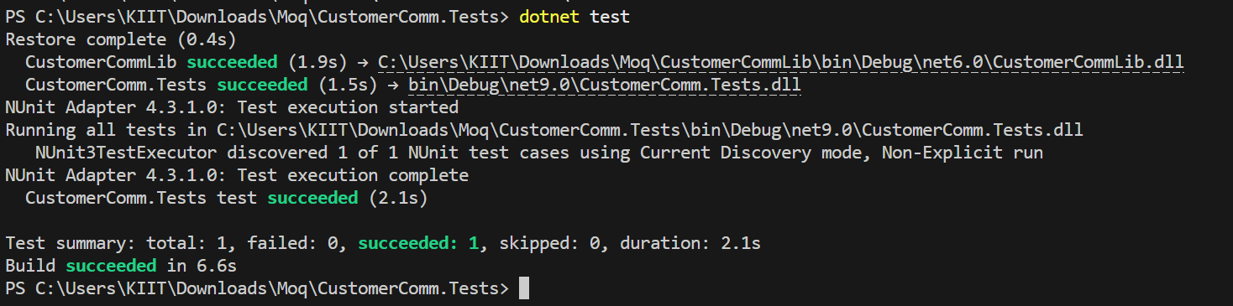

Mock file object for Unit Tests :

MagicFilesLib/DirectoryExplorer.cs

using System.Collections.Generic;
using System.IO;

namespace MagicFilesLib
{
public interface IDirectoryExplorer
{
ICollection<string> GetFiles(string path);
}

public class DirectoryExplorer : IDirectoryExplorer
{
public ICollection<string> GetFiles(string path)
{
string[] files = Directory.GetFiles(path);
return files;
}
}
}

DirectoryExplorer.Tests/DirectoryExplorerTests.cs

using Moq;
using NUnit.Framework;
using MagicFilesLib;
using System.Collections.Generic;

namespace DirectoryExplorer.Tests
{
[TestFixture]
public class DirectoryExplorerTests
{
private readonly string _file1 = "file.txt";
private readonly string _file2 = "file2.txt";
private IDirectoryExplorer _directoryExplorer;
[OneTimeSetUp]
public void Setup()
{
var mock = new Mock<IDirectoryExplorer>();
mock.Setup(x => x.GetFiles(It.IsAny<string>())).Returns(new List<string> { _file1, _file2 });
_directoryExplorer = mock.Object;
}
[Test]
public void GetFiles_ShouldReturnTwoFiles()
{
var files = _directoryExplorer.GetFiles("dummyPath");
Assert.IsNotNull(files);
Assert.AreEqual(2, files.Count);
Assert.Contains(_file1, (System.Collections.ICollection)files);
}
}
}

- Output:

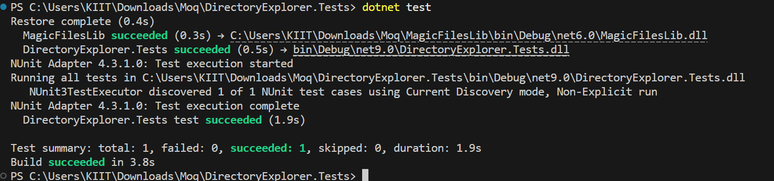

Mock database for Unit Tests :

PlayersManagerLib/PlayerManager.cs

using System;
using System.Data.SqlClient;

namespace PlayersManagerLib
{
public interface IPlayerMapper
{
bool IsPlayerNameExistsInDb(string name);
void AddNewPlayerIntoDb(string name);
}

public class PlayerMapper : IPlayerMapper
{
private readonly string _connectionString = "Data Source=(local);Initial Catalog=GameDB;Integrated Security=True";

public bool IsPlayerNameExistsInDb(string name)
{
using (SqlConnection conn = new SqlConnection(_connectionString))
{
conn.Open();
using (SqlCommand cmd = conn.CreateCommand())
{
cmd.CommandText = "SELECT COUNT(*) FROM Player WHERE Name = @name";
cmd.Parameters.AddWithValue("@name", name);
return (int)cmd.ExecuteScalar() > 0;
}
}
}

public void AddNewPlayerIntoDb(string name)
{
using (SqlConnection conn = new SqlConnection(_connectionString))
{
conn.Open();
using (SqlCommand cmd = conn.CreateCommand())
{
cmd.CommandText = "INSERT INTO Player (Name) VALUES (@name)";
cmd.Parameters.AddWithValue("@name", name);
cmd.ExecuteNonQuery();
}
}
}
}

public class Player
{
public string Name { get; private set; }
public int Age { get; private set; }
public string Country { get; private set; }
public int NoOfMatches { get; private set; }

public Player(string name, int age, string country, int matches)
{
Name = name;
Age = age;
Country = country;
NoOfMatches = matches;
}

public static Player RegisterNewPlayer(string name, IPlayerMapper playerMapper = null)
{
playerMapper ??= new PlayerMapper();

if (string.IsNullOrWhiteSpace(name))
throw new ArgumentException("Player name can’t be empty.");

if (playerMapper.IsPlayerNameExistsInDb(name))
throw new ArgumentException("Player name already exists.");

playerMapper.AddNewPlayerIntoDb(name);
return new Player(name, 23, "India", 30);
}
}
}

PlayerManager.Tests/PlayerManagerTests.cs

using Moq;
using NUnit.Framework;
using PlayersManagerLib;
using System;

namespace PlayerManager.Tests
{
[TestFixture]
public class PlayerManagerTests
{
private Mock<IPlayerMapper> _mockMapper;

[OneTimeSetUp]
public void Setup()
{
_mockMapper = new Mock<IPlayerMapper>();
_mockMapper.Setup(x => x.IsPlayerNameExistsInDb(It.IsAny<string>())).Returns(false);
}

[Test]
public void RegisterNewPlayer_ShouldReturnPlayerObject()
{
var player = Player.RegisterNewPlayer("Dhoni", _mockMapper.Object);
Assert.AreEqual("Dhoni", player.Name);
Assert.AreEqual(23, player.Age);
Assert.AreEqual("India", player.Country);
Assert.AreEqual(30, player.NoOfMatches);
}
}
}

- Output:

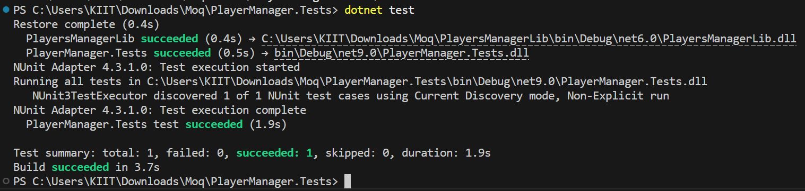

- NUnit

- NUnit Hands-On: Unit Testing Calculator Operations

CalcLibrary/Calc.cs

using System;

namespace CalcLibrary
{
interface IMathLibrary
{
double Addition(double a, double b);
double Subtraction(double a, double b);
double Multiplication(double a, double b);
double Division(double a, double b);
}

public class SimpleCalculator : IMathLibrary
{
double result = 0;

public double Addition(double a, double b)
{
result = a + b;
return result;
}

public double Subtraction(double a, double b)
{
result = a - b;
return result;
}

public double Multiplication(double a, double b)
{
result = a * b;
return result;
}

public double Division(double a, double b)
{
if (b == 0)
throw new ArgumentException("Second Parameter Can't be Zero");
result = a / b;
return result;
}

public void AllClear()
{
result = 0;
}

public double GetResult
{
get { return result; }
}
}
}

CalcLibrary.Tests/CalculatorTests.cs

using NUnit.Framework;
using CalcLibrary;
using System;

namespace CalcLibrary.Tests
{
[TestFixture]
public class CalculatorTests
{
private SimpleCalculator _calc;

[SetUp]
public void Setup()
{
_calc = new SimpleCalculator();
}

[TestCase(2, 3, 5)]
[TestCase(-1, -2, -3)]
public void Addition_ShouldReturnCorrectSum(double a, double b, double expected)
{
var result = _calc.Addition(a, b);
Assert.That(result, Is.EqualTo(expected));
}

[TestCase(5, 3, 2)]
[TestCase(0, -2, 2)]
public void Subtraction_ShouldReturnCorrectResult(double a, double b, double expected)
{
var result = _calc.Subtraction(a, b);
Assert.That(result, Is.EqualTo(expected));
}

[TestCase(4, 2, 8)]
[TestCase(-1, 5, -5)]
public void Multiplication_ShouldReturnCorrectResult(double a, double b, double expected)
{
var result = _calc.Multiplication(a, b);
Assert.That(result, Is.EqualTo(expected));
}

[TestCase(10, 2, 5)]
public void Division_ShouldReturnCorrectResult(double a, double b, double expected)
{
var result = _calc.Division(a, b);
Assert.That(result, Is.EqualTo(expected));
}

[Test]
public void Division_ByZero_ShouldThrowException()
{
Assert.Throws<ArgumentException>(() => _calc.Division(5, 0));
}

[TearDown]
public void Cleanup()
{
_calc = null;
}
}
}

- Output:

